Access Control:

How a member can be accessed is determined by the access modifier attached to its declaration.

Usually, you will want to restrict access to the data members of a class—allowing access only through methods.

Also, there will be times when you will want to define methods that are private to a class.

Java’s access modifiers are public, private, and protected. Java also defines a default access level.

protected applies only when inheritance is involved.

When no access modifier is used, then by default the member of a class is public within its own package,

but cannot be accessed outside of its package.

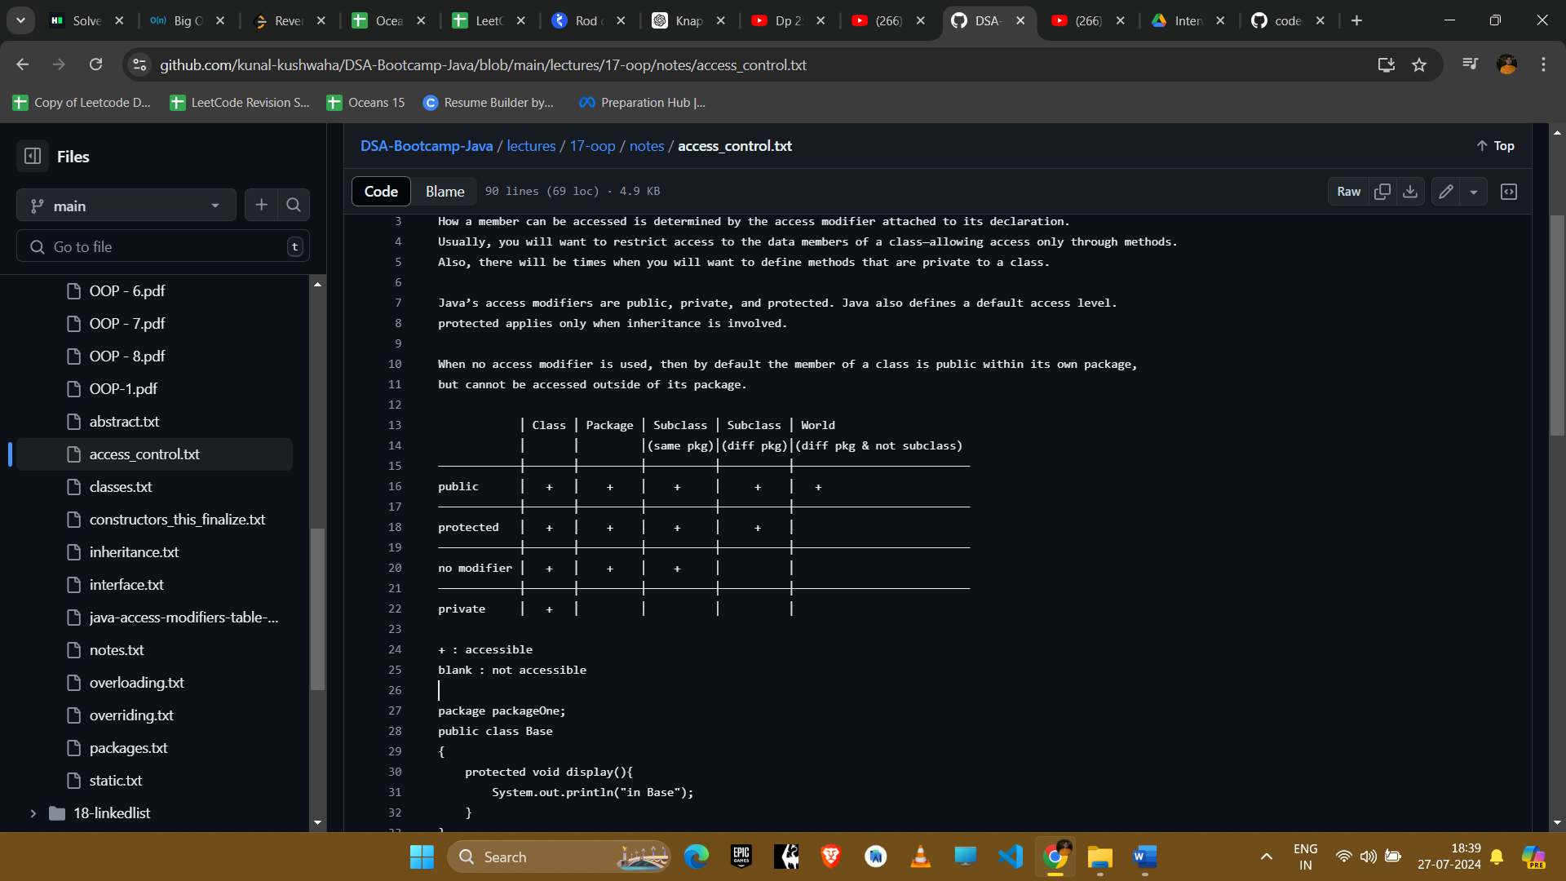

package packageOne;

public class Base

{

protected void display(){

System.out.println("in Base");

}

}

package packageTwo;

public class Derived extends packageOne.Base{

public void show(){

new Base().display(); // this is not working

new Derived().display(); // is working

display();//is working

}

}

protected allows access from subclasses and from other classes in the same package.

We can use child class to use protected member outside the package but only child class object can access it.

That's why any Derived class instance can access the protected method in Base.

The other line creates a Base instance (not a Derived instance!!).

And access to protected methods of that instance is only allowed from objects of the same package.

display();

-> allowed, because the caller, an instance of Derived has access to protected members and fields of its subclasses,

even if they're in different packages

new Derived().display();

-> allowed, because you call the method on an instance of Derived and that instance has access to the protected methods

of its subclasses

new Base().display();

-> not allowed because the caller's (the this instance) class is not defined in the same package like the Base class,

so this can't access the protected method. And it doesn't matter - as we see - that the current subclasses a class from

that package. That backdoor is closed ;)

Remember that any time talks about a subclass having an access to a superclass member, we could be talking about the

subclass inheriting the member, not simple accessing the member through a reference to an instance of the superclass.

class C

protected member;

// in a different package

class S extends C

obj.member; // only allowed if type of obj is S or subclass of S

The motivation is probably as following. If obj is an S, class S has sufficient knowledge of its internals,

it has the right to manipulate its members, and it can do this safely.

If obj is not an S, it's probably another subclass S2 of C, which S has no idea of.

S2 may have not even been born when S is written. For S to manipulate S2's protected internals is quite dangerous.

If this is allowed, from S2's point of view, it doesn't know who will tamper with its protected internals and how,

this makes S2 job very hard to reason about its own state.

Now if obj is D, and D extends S, is it dangerous for S to access obj.member? Not really.

How S uses member is a shared knowledge of S and all its subclasses, including D. S as the superclass has the right to

define behaviours, and D as the subclass has the obligation to accept and conform.

For easier understanding, the rule should really be simplified to require obj's (static) type to be exactly S.

After all, it's very unusual and inappropriate for subclass D to appear in S. And even if it happens,

that the static type of obj is D, our simplified rule can deal with it easily by upcasting: ((S)obj).member